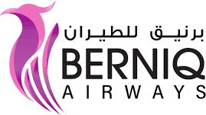

BERNIQ AIRWAYS

Hawari - Independence Str.
Benghazi, Libya

TEL: +218 92 6204516
FAX: +218 61 2240198
www.berniq.com

BERNIQ AIRWAYS Operations Manual PART A:

Edition 01/Revision 00 – FEBRUARY 15,2026

Email:

Copy N°: …………………………………

Holder: ………………………………………………………………………

Foreword

This Operations Policy Manual is produced by BERNIQ AIRWAYS Flight Operations.

It is a guide to BERNIQ AIRWAYS crews based on LIBYAN CAA requirements.

Its content does not supersede any requirements mandated by the LIBYAN CAA nor does it supersede or amend fleet type specific documentations such as AFM,FCOM, MMEL or any other approved documentation.

This manual contains guidelines, regulations and examples that adapted to BERNIQ AIRWAYS policies and regulations.

Use and duplication (in whole or part, in all media) of this manual is authorized for internal purposes of BERNIQ AIRWAYS departments only. Any commercial use is strictly excluded.

Any questions with respect to information contained in this manual should be directed to:

FLIGHT OPERATIONS OFFICE:

Hawari - Independence Str, P.O.Box17570
Benghazi, Libya

EMAIL:

